MadL
- Dread Pyrate
- Member

- 1,283 posts
- Gender:Male
- Location:Where ever I need ta be
- Interests:I like pirates, ye got a problem with that?
Blame me mu'm, she the one who decked me room out like a captain's cabin an' that be what I grew'd up in. Also me pa fer he built boats when I was but a wee lad. Later they ran off an' joined the carnivals, so I learn ta be a scalawag from the best.
I like weapons, some that go BOOM, and always sharp shiny ones.
I work with computers, currently contracted to hire by Xerox, their engineers [I]Need[/I] all the help they can get, this is fer sure! But I also have taught the Microsoft Certification course for a private contact school, an' spent 4 years working third level support at Earthlink before that scalawag Sky jumped ship an' let it go down.
They call me Mad L cuz, well, cuz many think I be mad, mad as a hatter they say but that only because they never jumped from a perfectly good airplane....over a thousand times. They also call me Mad L cuz I don't much like dogs n' cats, but I like things with scales and teeth, even the venomous ones for they be quit tasty when roasted over an open flame....even bet'r wit rum! They also call me Mad L, well, cuz very few know how to say me sir name properly, so in the military they give up and just call me "Mad L"
Oh, an' I dabble in the arts, computer 3D arts that be. Thar they all think I be mad, I do me best to make sure they all know I be mad. I have fun run'n amok as a pirate monkey character and makin' the moderators thar go bald. Several times the moderators try ta toss me o'r board, but the crew say will have none o' that now ;\
So, I like pirates, ye got a problem with that?
(IP: 75.56.208.193) ·
Posted April 22, 2012 · Report post
I am seeking further information on a story I recently heard about: Pirate Gambling Markers
A recent documentary (some times also docu-mockery) about the search for the sunken remains of The Fiery Dragon has turned up what they say is a "Gambling Marker". They told that they were "first found at the site of The Whydah" and now half way around the world in Madagascar in a wreckage belived to be that of The Fiery Dragon.
The gambling marker is described to be about the size of a postage stamp and bears an 'X' on it; one picture they showed indicates there may be other marking on the opposite side, perhaps that of a coin. The area indicates that the newest one found is from around 1712. They stated that these 'gambling markers' are "Known exclusively to Pirates" - it was said "Since gambling for money was forbbin on ship, to avoid temptations and throat slittings, pirates would use these markers in their games to represent the money they would be paid once on land".
As they say these markers where found upon The Whydah and now also upon The Fiery Dragon, I thought I could find further information about their useage, values, etc - but so far nothing has turned up.
Anyone else heard this story, anyone been able to track down further information on these Gambling Markers and their use in game?

- Quote
- Edit

RIPP Tar
- First Mate
- Member

- 266 posts
- Gender:Male
- Location:Rhode Island
- Interests:Piracy in Rhode Island
(IP: 68.9.211.62) · ·
Posted April 22, 2012 · Report post
I think i've seen the same show. It is possible that they actually held no value, treated more like a game piece. But like you this was the only place I have heard of them.

- Quote
- Edit
- Options

Grymm
- First Mate
- Member

- 281 posts
- Gender:Male
- Location:Chilterns UK
- Interests:Stuff
(IP: 86.183.160.158) · ·
Posted April 22, 2012 (edited) · Report post
Tokens(locally produced 'currancy'), jettons and gaming pieces........ like shingle on a beach, but admitting that won't sell TV progs =o/
For a good overview on Mother of Pearl gambling tokens (We'd prob'ly call'em chips these days) this chap http://chezbill.com/ is very good, obsessed but then no more than we are about different stuff.
Ditto about tokens http://www.tokensoci....uk/index.shtml
And a random selection of tokens, jettons and gaming/gambling pieces

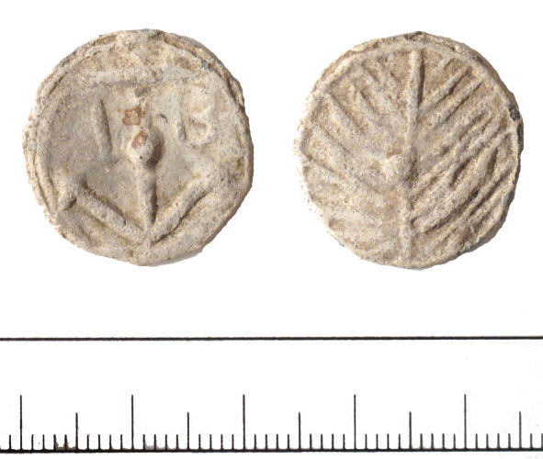
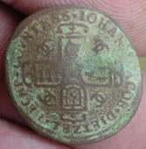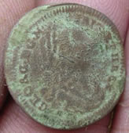
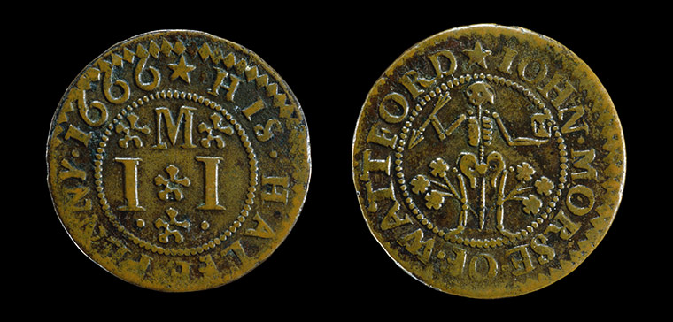
I wonder what a future society will think these were for
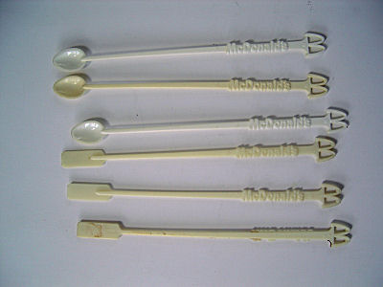
Only joking =o) But I remember playing poker using these and matchsticks, a McD stirrer was worth 10 matchsticks.
Edited April 22, 2012 by Grymm

- Quote
- Edit
- Options

Fox
- Old Twillian
- Moderator

- 2,564 posts
- Gender:Male
- Location:Beautiful lush Devon, England
- Interests:Nautical history of the 16-18th centuries and living history based thereon.
Shooting pirates.
(IP: 86.164.201.12) · ·
Posted April 22, 2012 · Report post
Did anyone else just pee in their pants at the 1666 depiction of an 'anatomie' with an hourglass and a dart? No? Just me?

- Quote
- Edit
- Options

jendobyns
- Pyrate Captain
- Member

- 562 posts
- Gender:Female
- Location:Baltimore
- Interests:too numerous to mention, really. Period foodways, baroque dance, material culture, etc., etc.
(IP: 72.81.199.132) · ·
Posted April 22, 2012 · Report post
Weren't these tokens (when used as local currency) also used by taverns and the like? Seem to remember that from my Annapolis archaeology days.

- Quote
- Edit
- Options

Capt. Sterling
- Sticky Fingers Sterling Needs a New Hat
- Member

- 10,302 posts
- Gender:Pyrate Hunter
- Location:here
- Interests:Killing pirates, haven't met one yet worth keeping alive....
(IP: 67.237.180.88) · ·
Posted April 22, 2012 · Report post
On 4/22/2012 at 6:49 PM, Foxe said:
Did anyone else just pee in their pants at the 1666 depiction of an 'anatomie' with an hourglass and a dart? No? Just me?
Now Foxe t'is but a shaft embedded in a bush.... of roses...ahem... or some sort of flowers....

- Quote
- Edit
- Options

Mission
- Goat Specialist
- Admin

- 5,082 posts
- Gender:Male
- Location:Monroe, MI
- Interests:Scholarly piracy, designing and creating haunted house rooms and props, movies, abstract thinking, abstruse thinking, obstructive thinking, ideating, random thinking, movies, cartoons, movies, movies scores, cycling, world peace and small furry dogs, movies, writing, drawing, personal skills training, gremlins and, of course, lest I forget, movies.
(IP: 24.247.94.112) · ·
Posted April 23, 2012 (edited) · Report post
On 4/22/2012 at 6:49 PM, Foxe said:
Did anyone else just pee in their pants at the 1666 depiction of an 'anatomie' with an hourglass and a dart? No? Just me?
Just before I saw it, it occurred to me that it could either be the source for BB's flag or the source for the person who tried to draw BB's flag. Although it predates him by a pretty significant span of years. (It also occurred to me that this was one of the years of the plague as well as the year of the great fire in London. FWIW.)
Edited April 23, 2012 by Mission

- Quote
- Edit
- Options

Capt. Sterling
- Sticky Fingers Sterling Needs a New Hat
- Member

- 10,302 posts
- Gender:Pyrate Hunter
- Location:here
- Interests:Killing pirates, haven't met one yet worth keeping alive....
(IP: 65.160.148.76) · ·
Posted April 23, 2012 · Report post
FWIW the Ft. Taylor ID pod was based on the wooden tokens that were used at coffee houses...

- Quote
- Edit
- Options

Fox
- Old Twillian
- Moderator

- 2,564 posts
- Gender:Male
- Location:Beautiful lush Devon, England
- Interests:Nautical history of the 16-18th centuries and living history based thereon.
Shooting pirates.
(IP: 195.194.74.65) · ·
Posted April 23, 2012 · Report post
On 4/23/2012 at 8:19 AM, Mission said:
Just before I saw it, it occurred to me that it could either be the source for BB's flag or the source for the person who tried to draw BB's flag. Although it predates him by a pretty significant span of years. (It also occurred to me that this was one of the years of the plague as well as the year of the great fire in London. FWIW.)
Not BB's flag - that's another of those horrid modern inventions - but certainly other pirates had flags with a similar device. My thoughts on the token are that a: it's nice to see an actual period depiction of a device I've only seen written about, and b: the fact that the token predates the pirate flags by 50+ years shows that it's not a 'pirate' symbol per se.
I hadn't even noticed the bush that looks like an enormous dangling todger...

- Quote
- Edit
- Options

Grymm
- First Mate
- Member

- 281 posts
- Gender:Male
- Location:Chilterns UK
- Interests:Stuff
(IP: 86.183.160.158) · ·
Posted April 23, 2012 · Report post
Thought you'd all like it =o)

